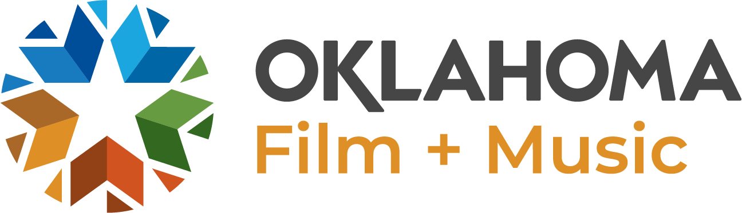

FILM/MUSIC BUSINESS OF THE MONTH QUESTIONS
Can you tell us how and why you started your business?

What services do you provide within the film/music industry?

How has your company grown to meet the needs of Oklahoma's film and/or music industries over the last 3-5 years?

What are the benefits of basing your company's operations in Oklahoma?

What would you consider your business’s greatest accomplishment to date?

Are there any recent successes your company would like to highlight related to work within the Oklahoma film and music industries?

What are you working on now/next?

What is your goal/vision for the future of your company?

What advice do you have for others who are considering starting a film or music business in Oklahoma?

What opportunities do you believe await Oklahoma’s film/music industry in the future?

Please provide a short description of your company to include as an introduction ahead of the questionnaire.
Example: Based in Oklahoma City, Gardocki Digital specializes in state-of-the-art visual effects and compositing for film, television, and the web.

