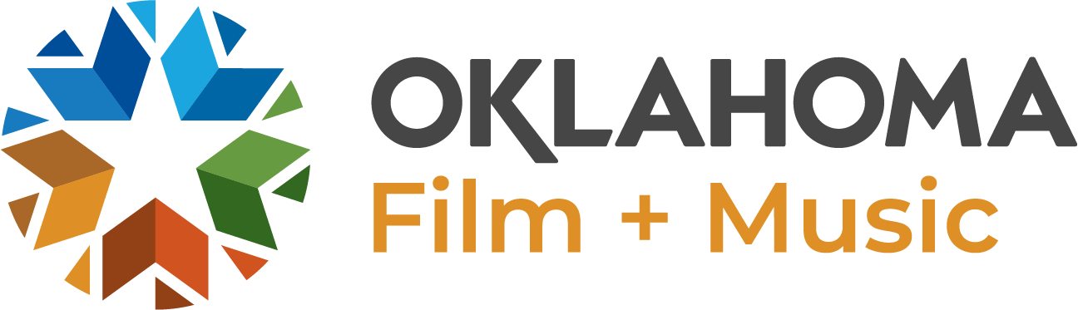

FEATURED MUSIC CAREER OF THE MONTH QUESTIONS - NEWSLETTER

How did you get started? (Education, etc..)

Did you always want a career in the music industry?

What is your role in the music industry? (Artist, audio engineer, promoter, music supervisor, retailer, producer, teacher)

Most Recent Successes / Placements / Accomplishments / Projects? Career highlight?

What is your favorite Oklahoma music venue, music store, or recording studio?

Networking and connecting with others who share your dream or vision is a vital aspect to the music industry. Can you share which Oklahoma organizations (if any) have contributed to your success and are there Oklahoma organization you would recommend other connect with? To help further their craft or promotion?

How can we follow you? Best place to purchase and listen to your music (if applicable)?

Advice for someone interested in working in the music industry.

What are some of the benefits of having a music career in Oklahoma? (Low cost of living? Talented musicians/producers?)

Favorite quote (if applicable)
Please provide a short (3 sentence) biography about yourself.
Example: Jennifer Maynord is the Founder & Director of Artio Services, a creative artist agency connecting arts and business to positively shape communities and company cultures. Her female-led team serves businesses and artists through consulting, art curation, bookings, and events, and helps people and projects flourish through arts influencing. She is also a music artist with the band Willow Way and lives and works in Oklahoma City, OK.

